**ITE5315 Assignment 2**

**N01579863 – Kush Patel**

**Web programming and Framework 1**

**Step 1: Create new Node/Express app as follow**

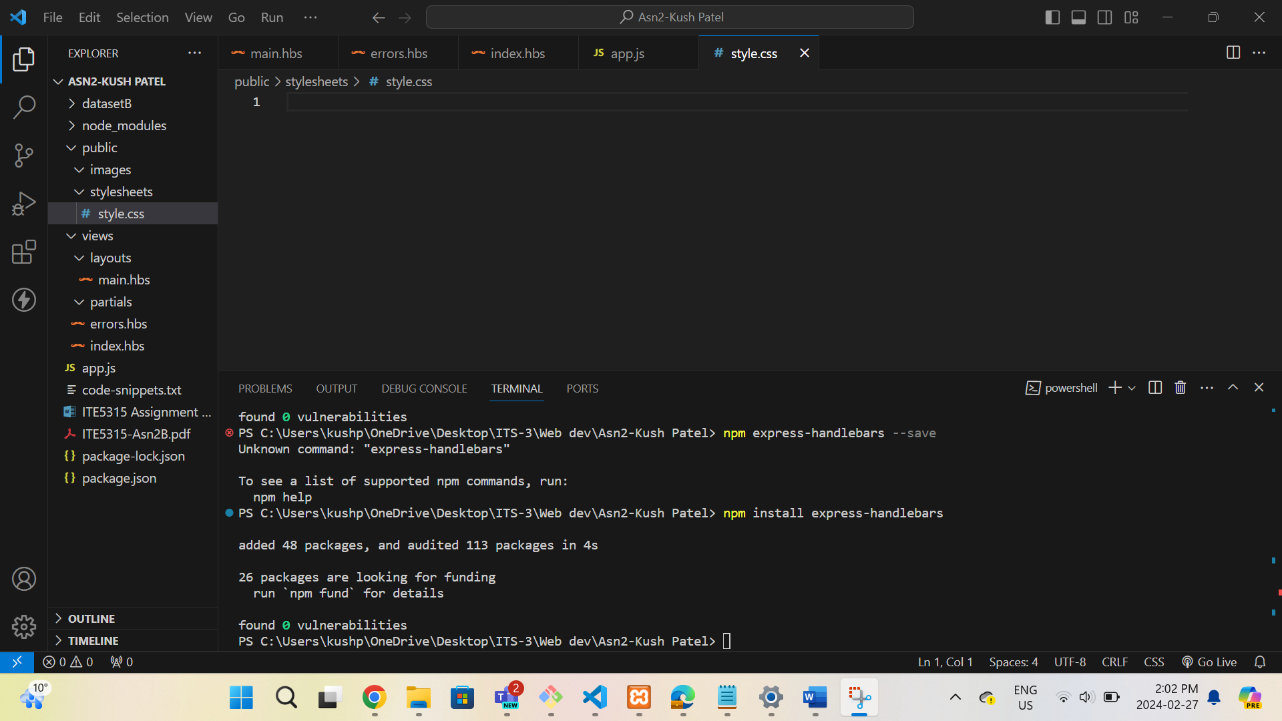

**Step 2: Using the attach file (codenippet.txt), copy/paste the related code to “style.css”,**

**“main.hbs”, “index.hbs”, “error.hbs” and “app.js”.**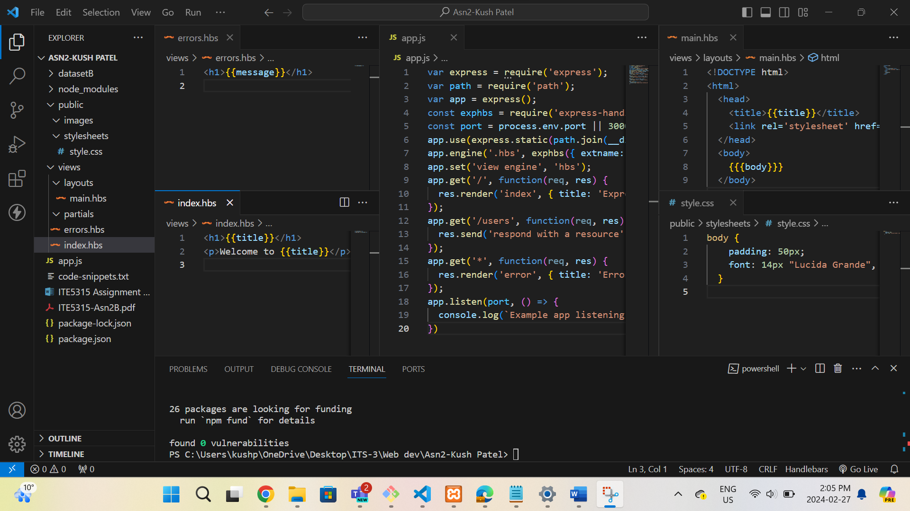

**Step 3:**

**URL: http://localhost:3000/**

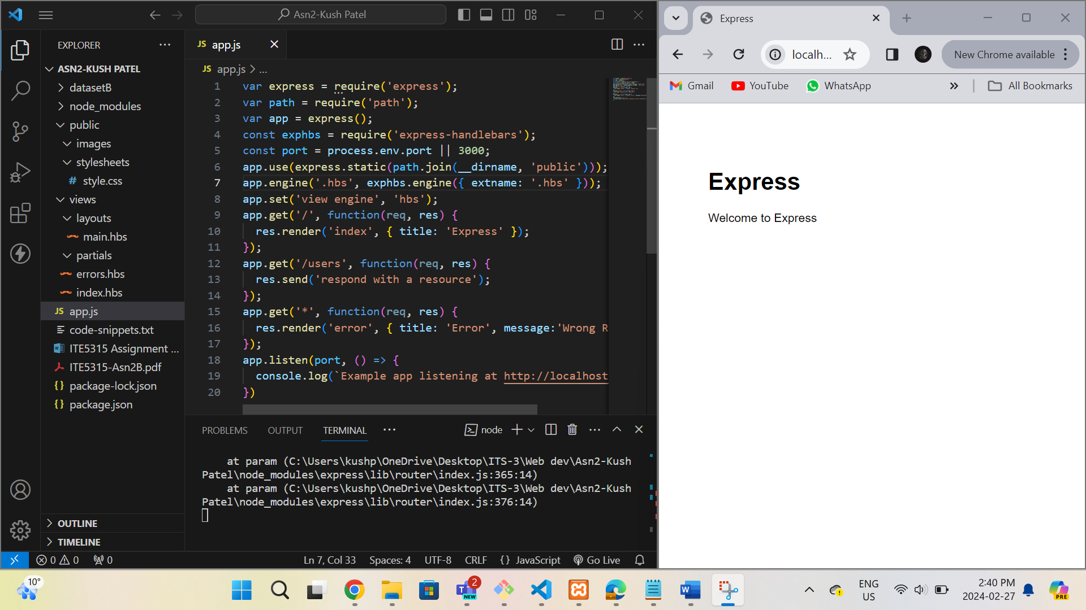

**URL:** [**http://localhost:3000/users**](http://localhost:3000/users)

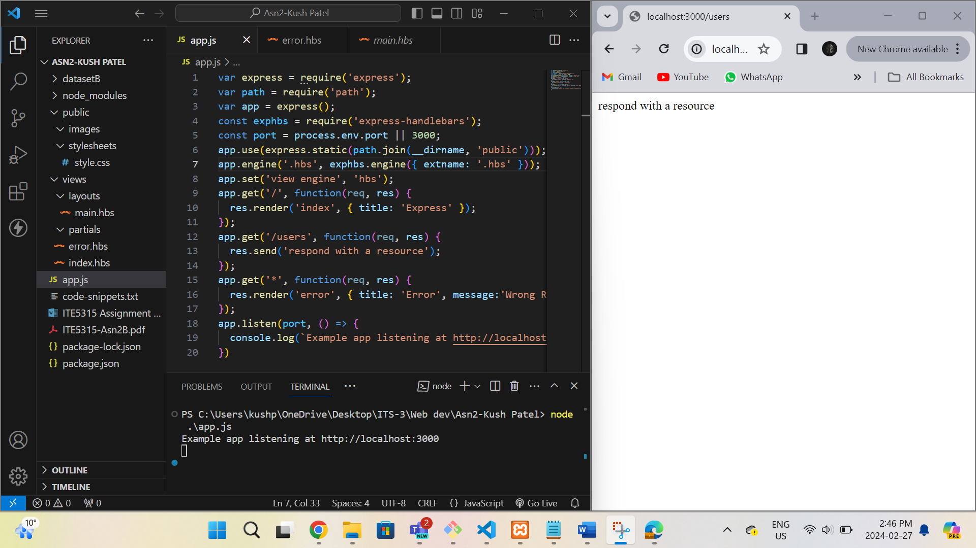

**URL:** [**http://localhost:3000/notExist**](http://localhost:3000/notExist)

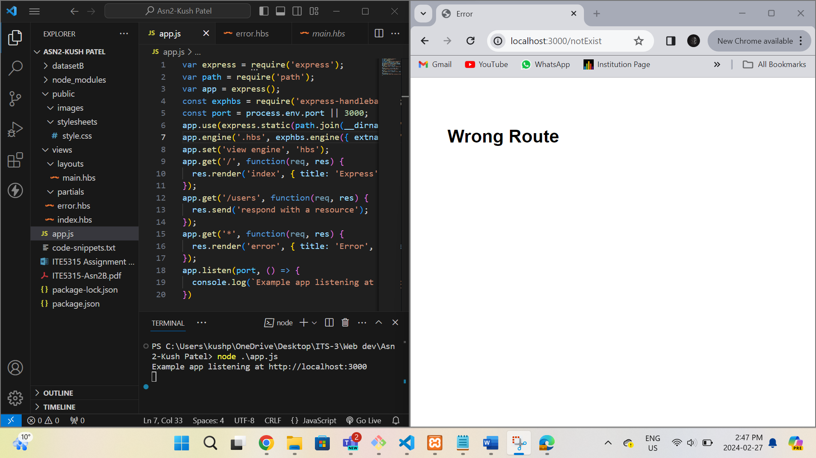

**Step 4:**

**Step 5:**

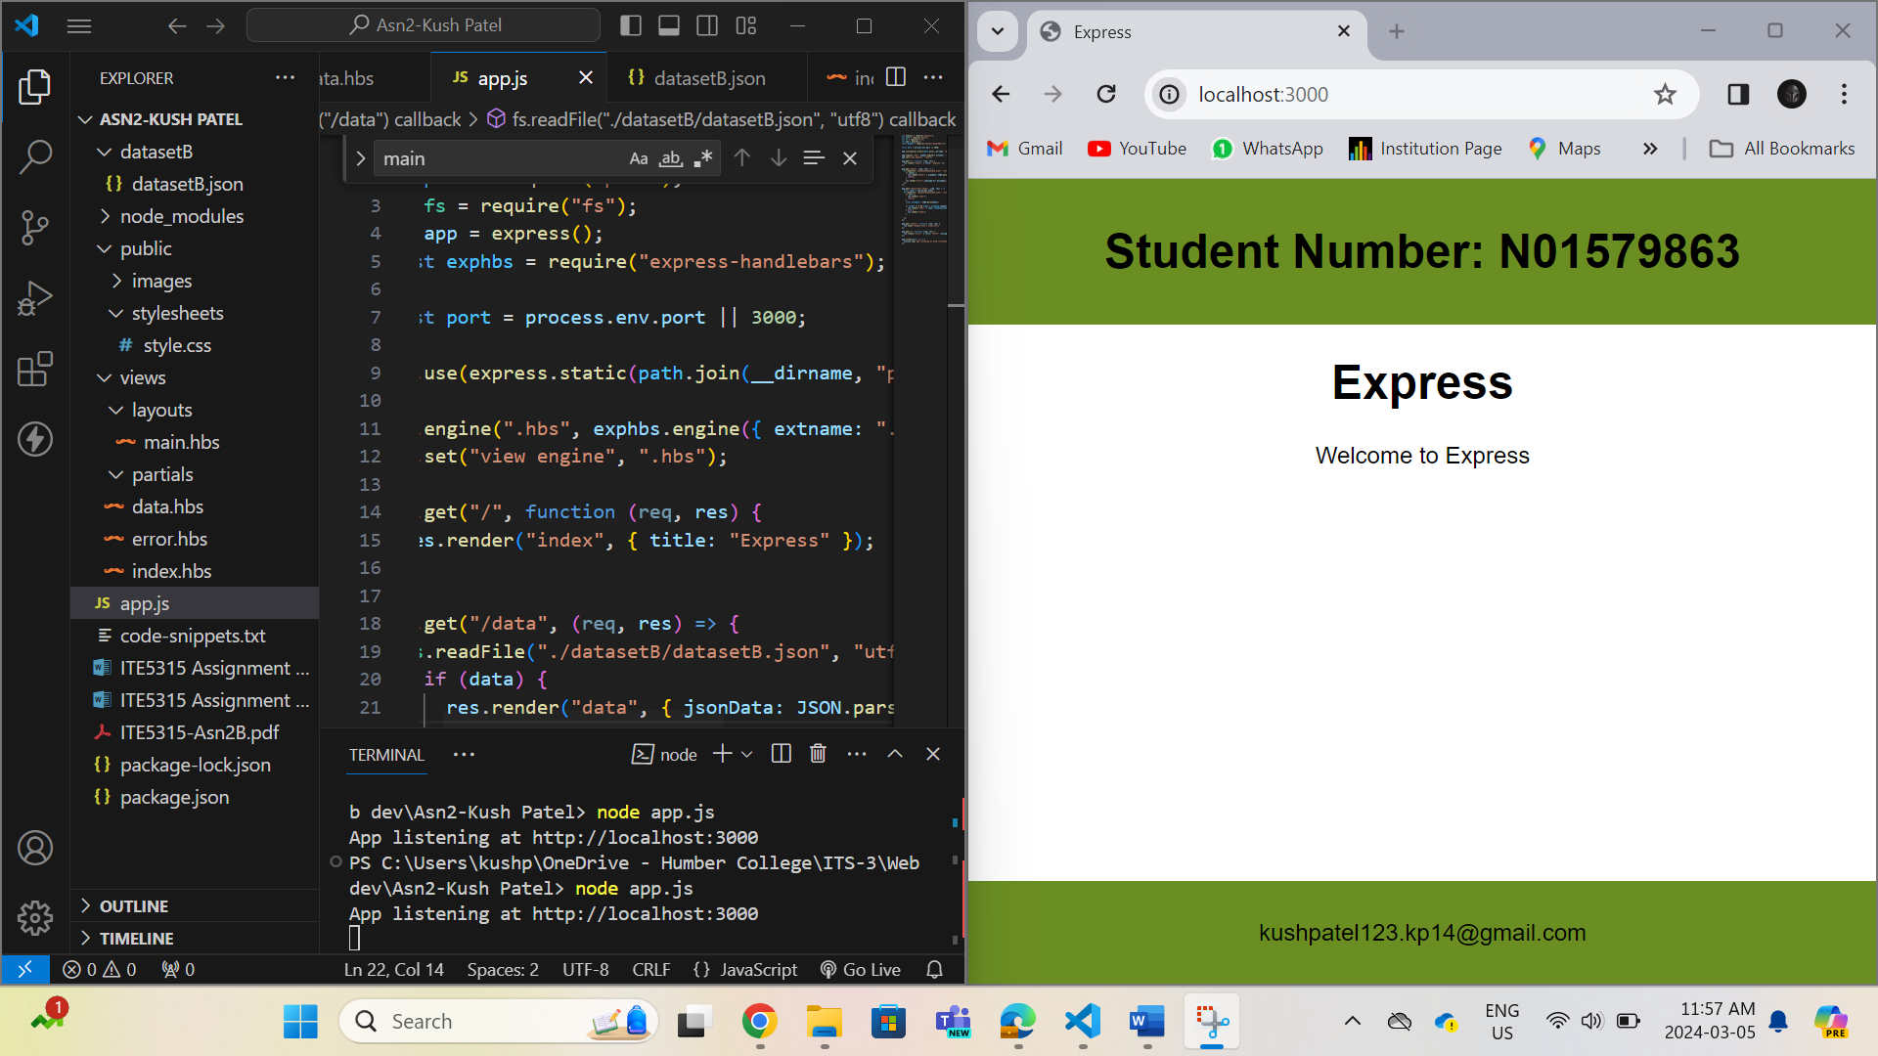

**Step 6:**

**URL –** [**http://localhost:3000/data**](http://localhost:3000/data)

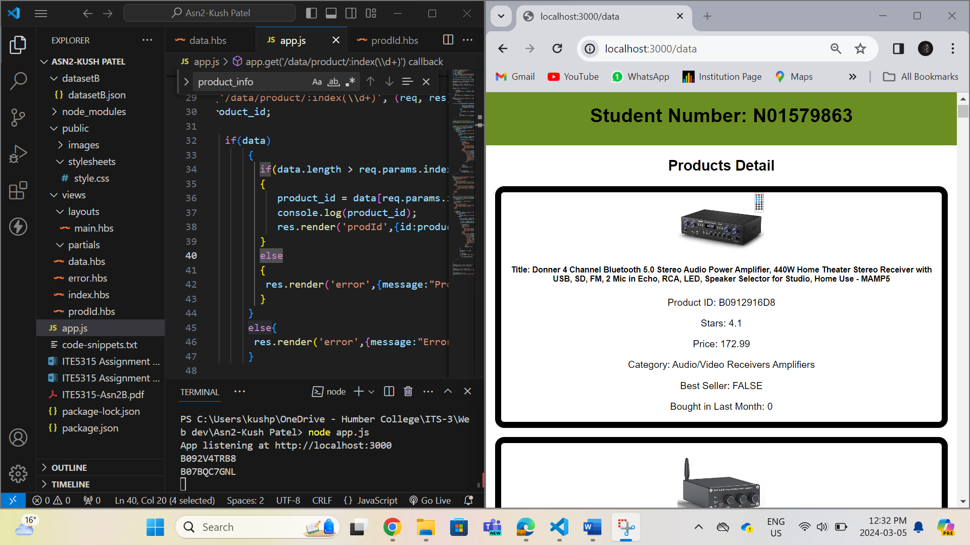

**URL -** [**http://localhost:3000/data/product/1**](http://localhost:3000/data/product/1)

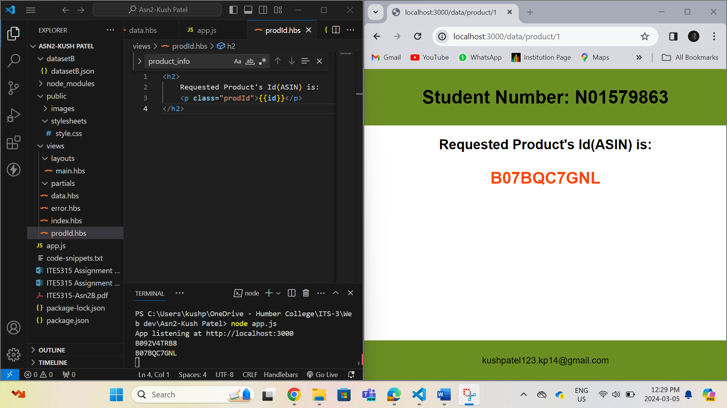

**URL -** [**http://localhost:3000/data/product/1787878787**](http://localhost:3000/data/product/1787878787)

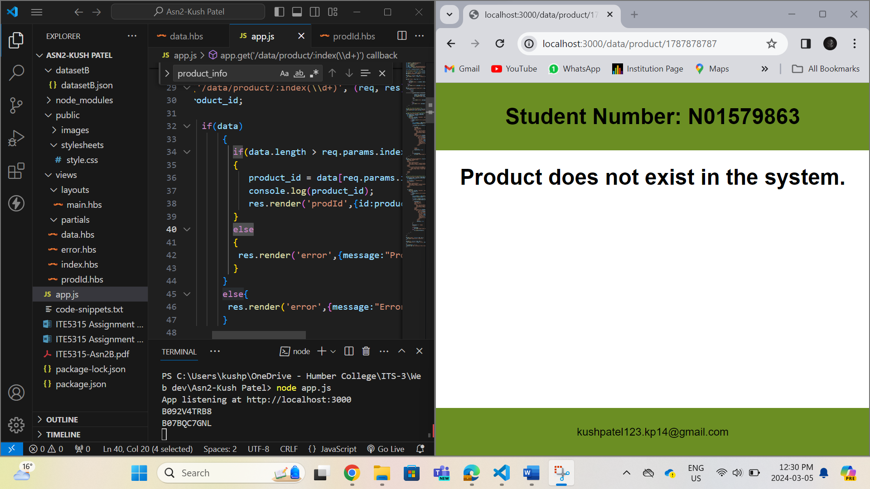

**URL -** [**http://localhost:3000/data/search/prdIDform**](http://localhost:3000/data/search/prdIDform)

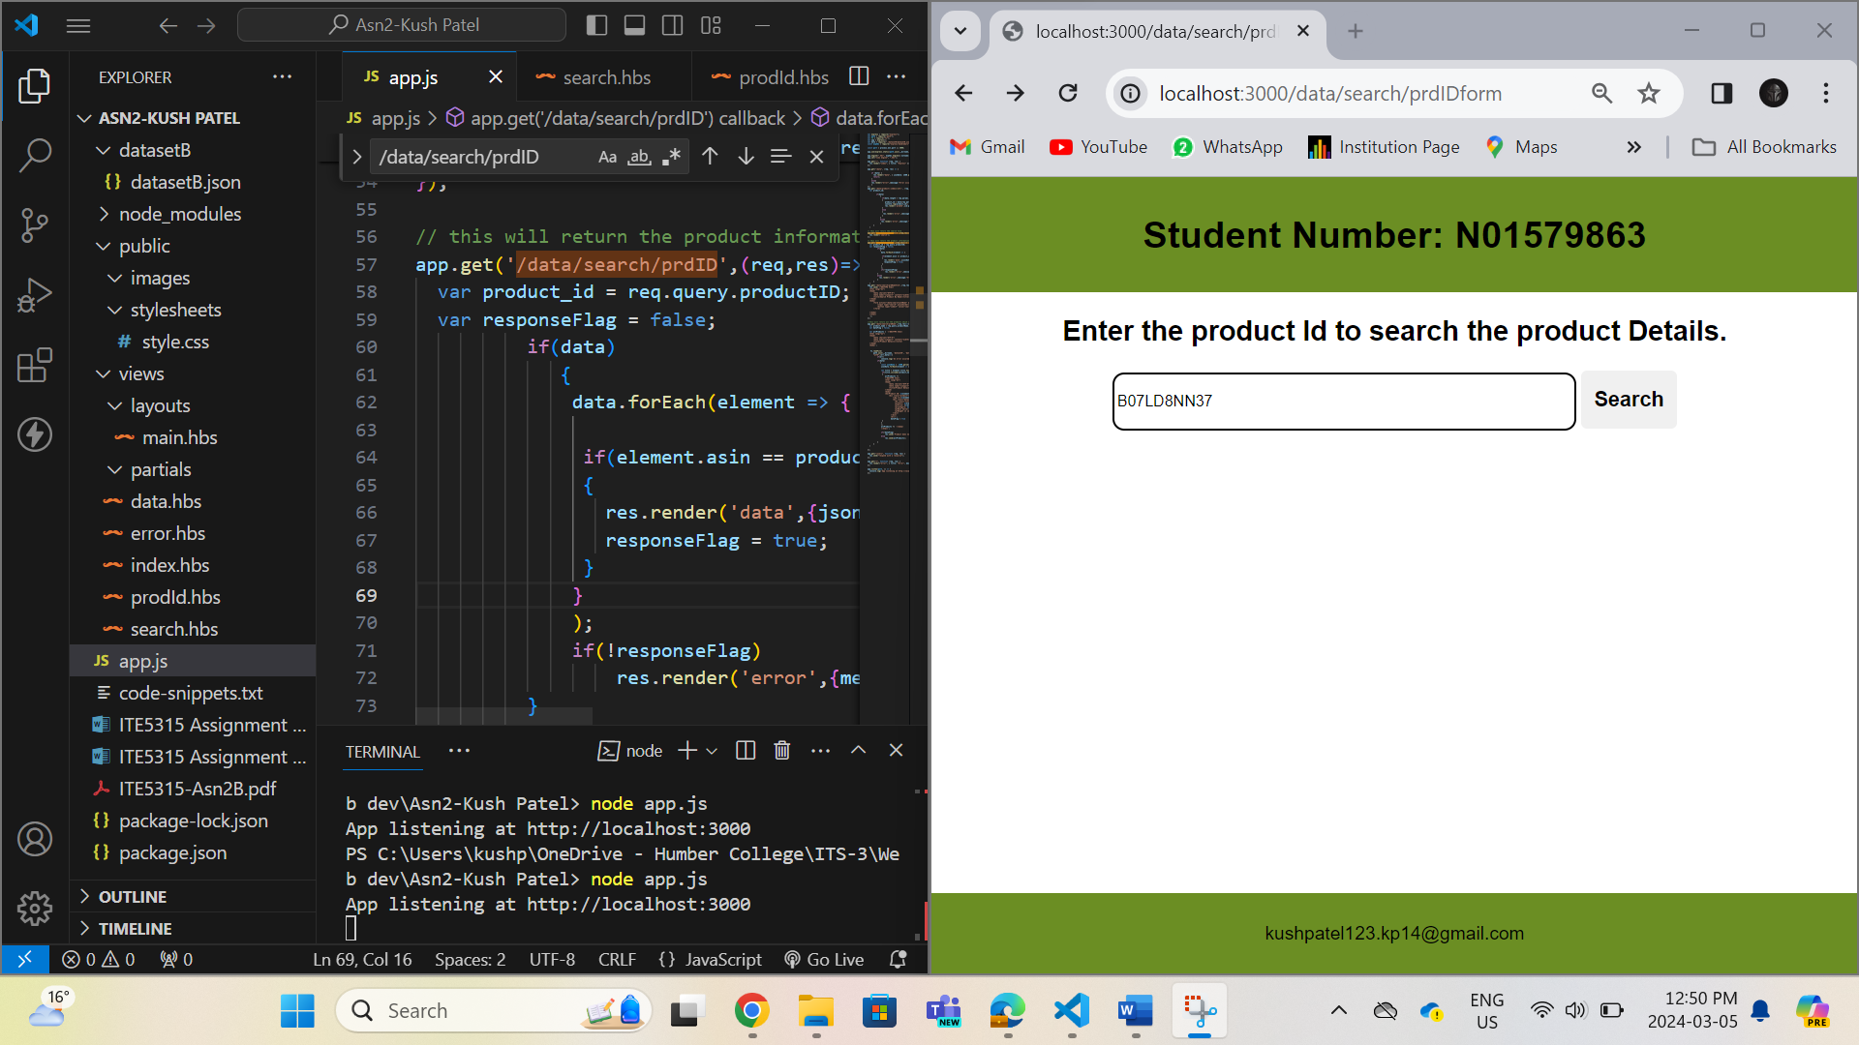

**URL -** [**http://localhost:3000/data/search/prdID?productID=B07LD8NN37**](http://localhost:3000/data/search/prdID?productID=B07LD8NN37)

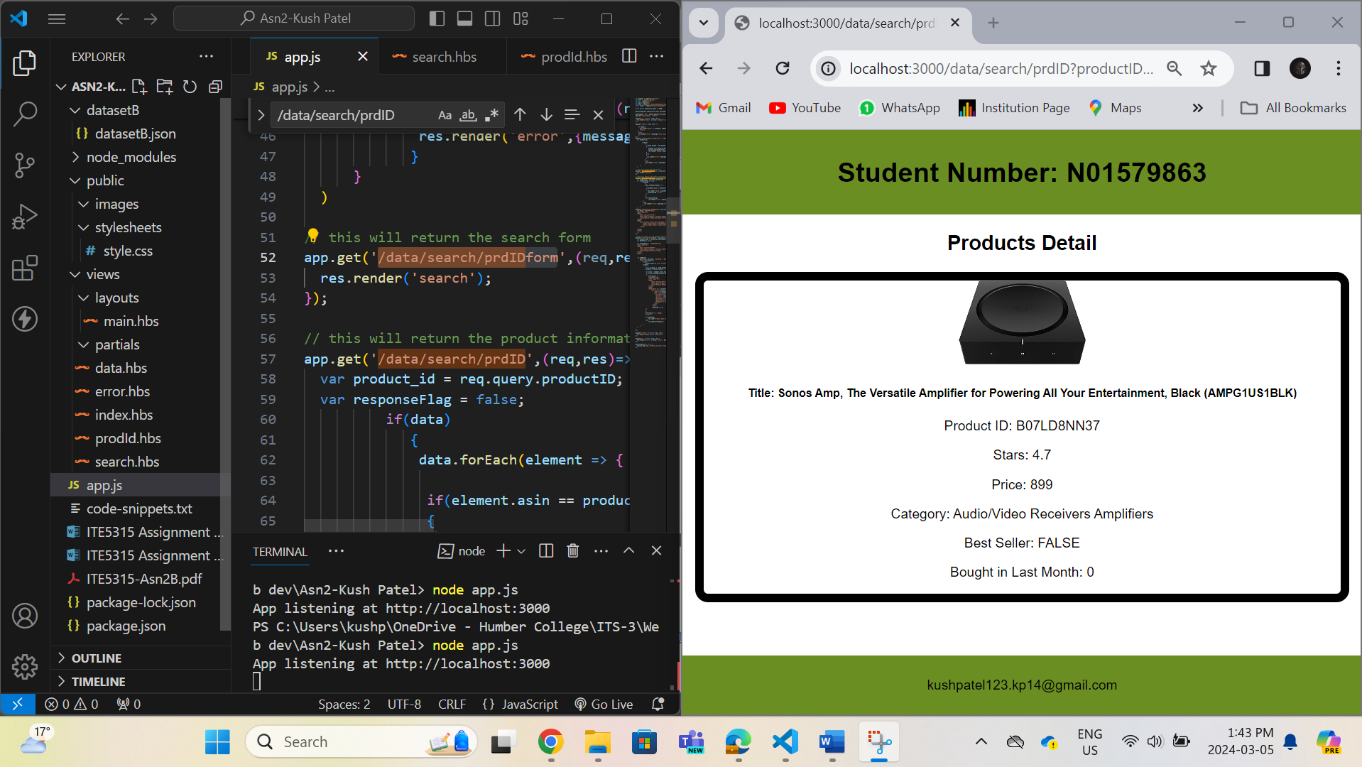

**URL –** [**http://localhost:3000/data/search/prdNameform**](http://localhost:3000/data/search/prdNameform)

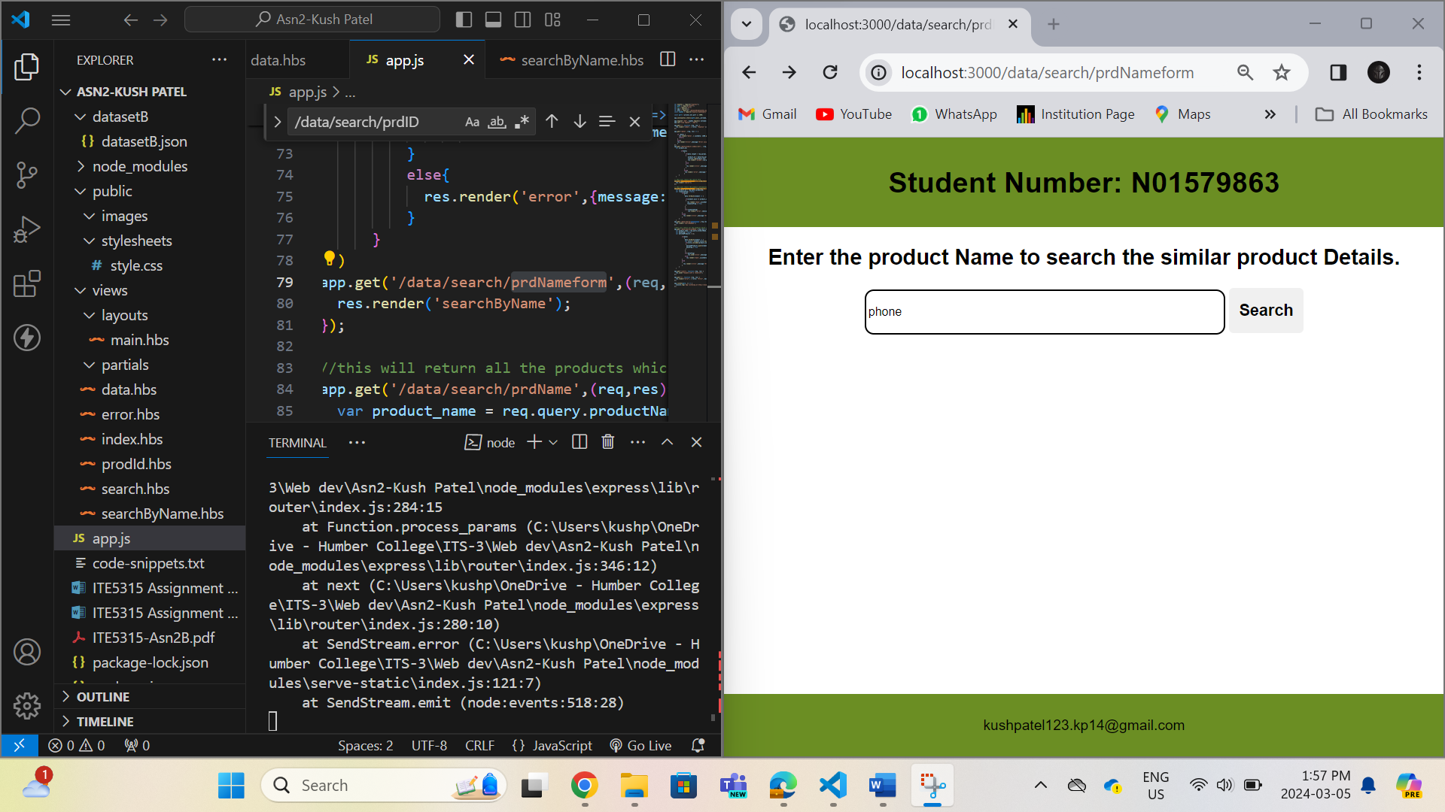

**URL –** [**http://localhost:3000/data/search/prdName?productName=phone**](http://localhost:3000/data/search/prdName?productName=phone)

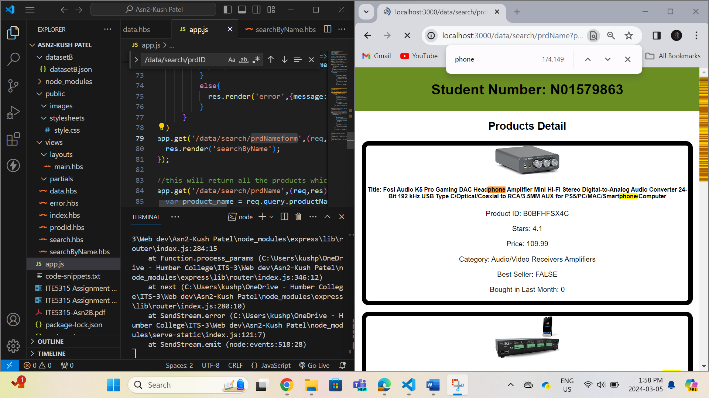

**Step 7:**

**URL –** [**http://localhost:3000/allData**](http://localhost:3000/allData)

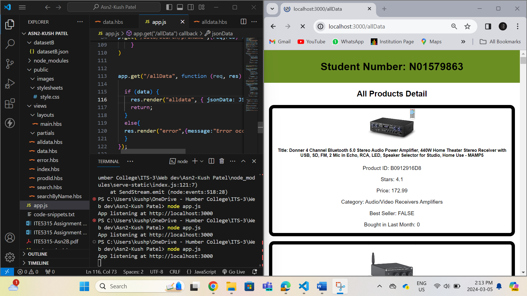

**Step 8:**

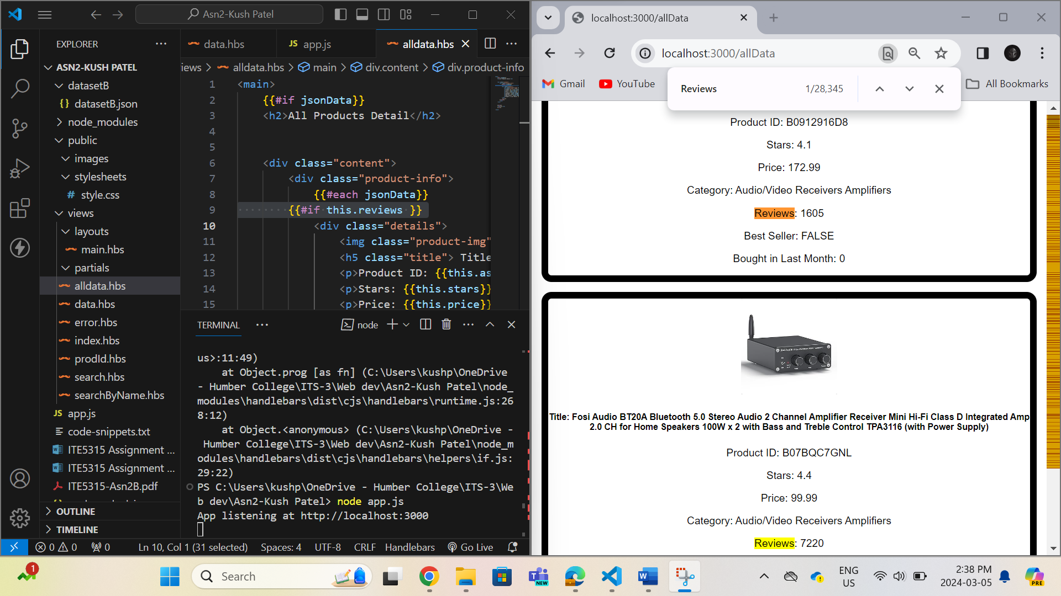

**Step 9:**

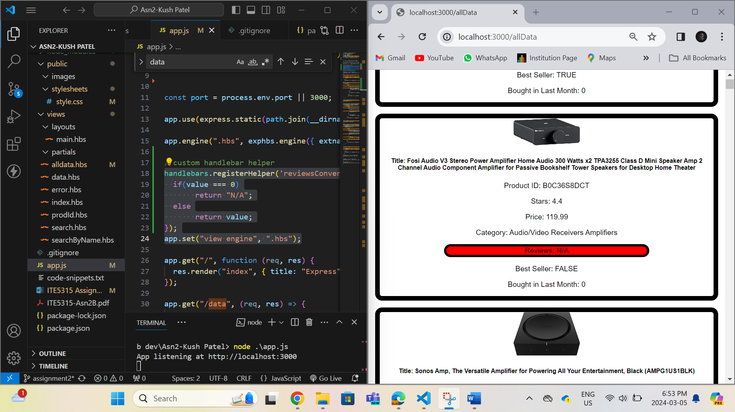

**Step 10:**

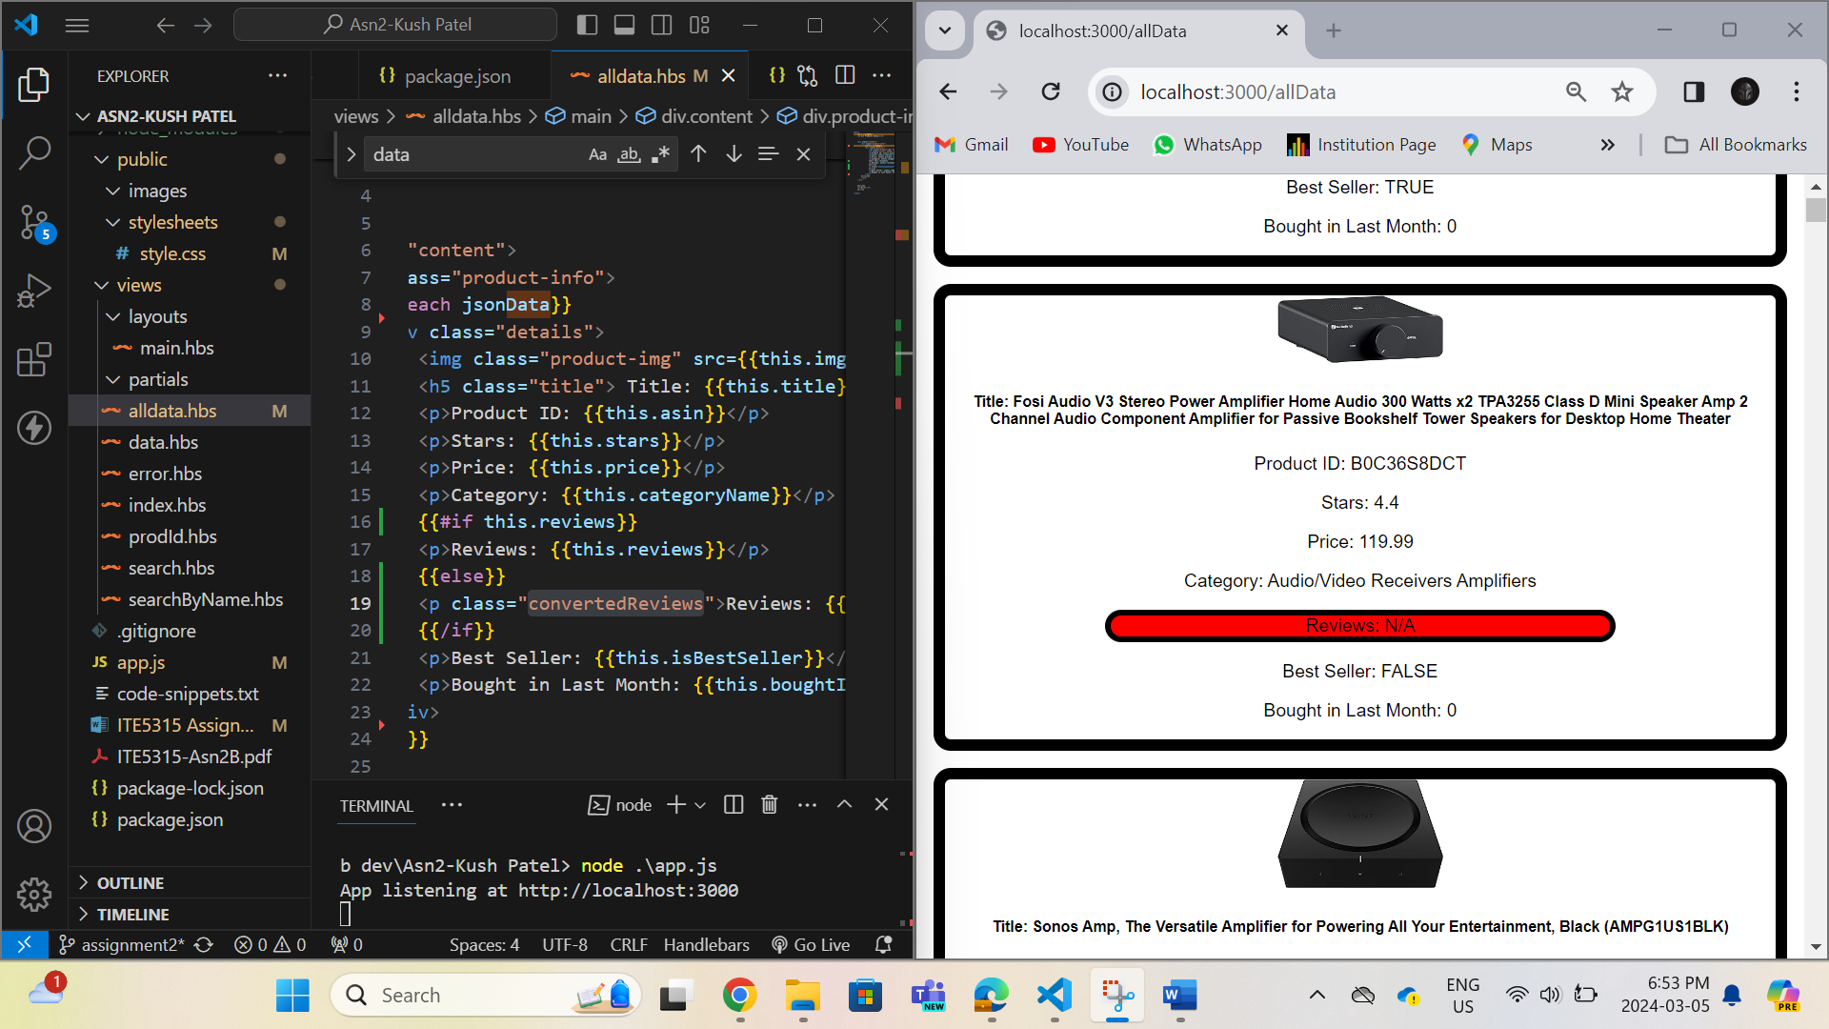

**Step 11:**

**URL -** [**https://fair-erin-snapper-hose.cyclic.app/**](https://fair-erin-snapper-hose.cyclic.app/) **this is the base url to access all the routes.**

